Library Management System Assignment

Scenario:

A library maintains records of books, members, and book loans. You are tasked to create a database to manage the library and write queries to interact with it.

Schema

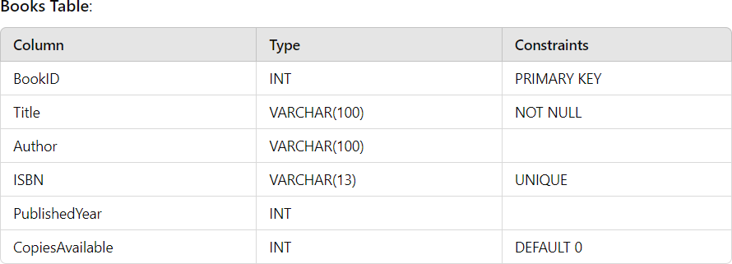

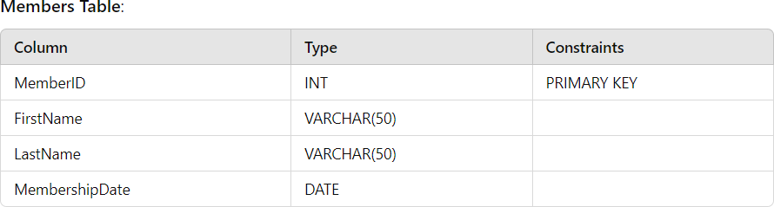

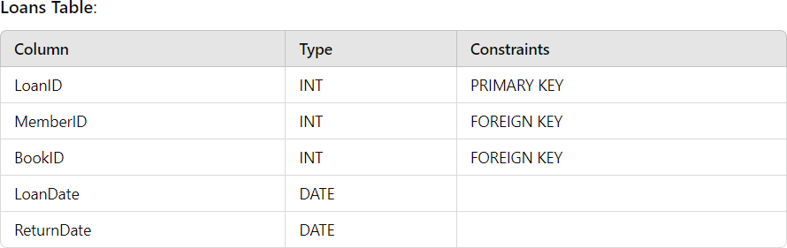

# Assignment Tasks

## Part 1: Creating the Database and Tables

1. Write a query to create a database named LibraryDB.

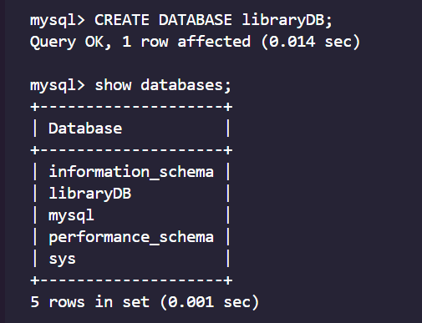

1. Create the Books table with the columns and constraints mentioned above.

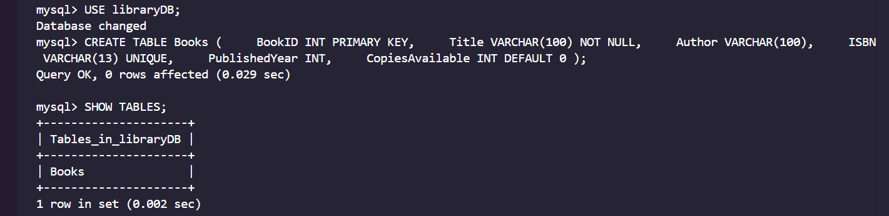

1. Create the Members table with the columns and constraints mentioned above.

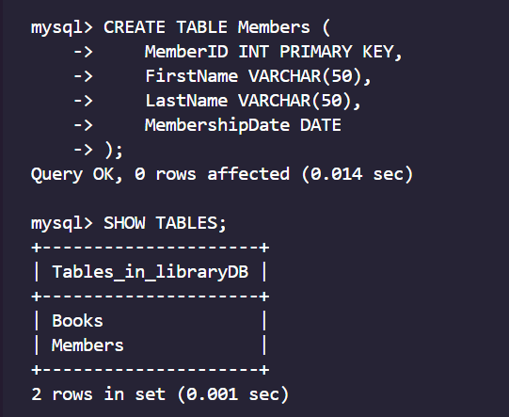

1. Create the Loans table with the columns and constraints mentioned above.

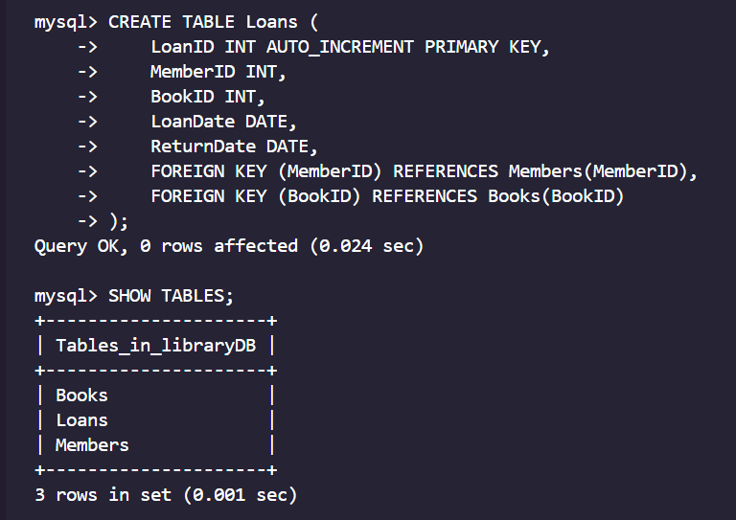

## Part 2: Inserting Data

1. Insert at least 5 records into the Books table.

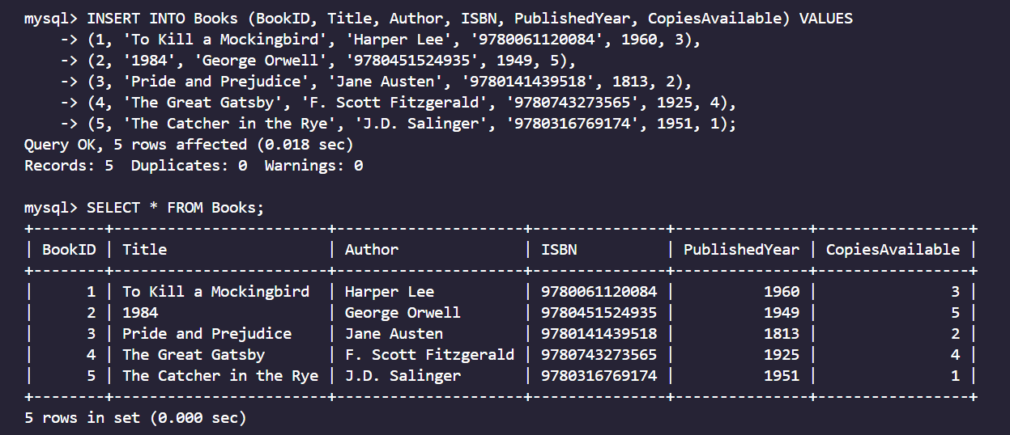

1. Add 3 members to the Members table.

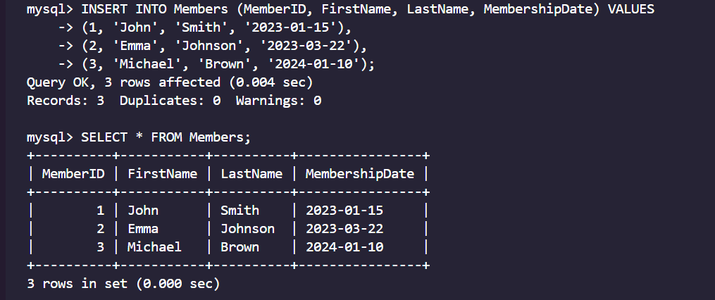

1. Create at least 2 records in the Loans table to track book loans.

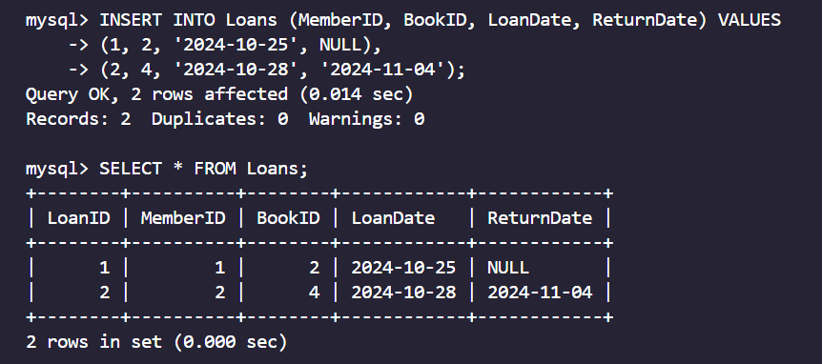

## Part 3: Basic Queries

1. Write a query to list all books in the library.

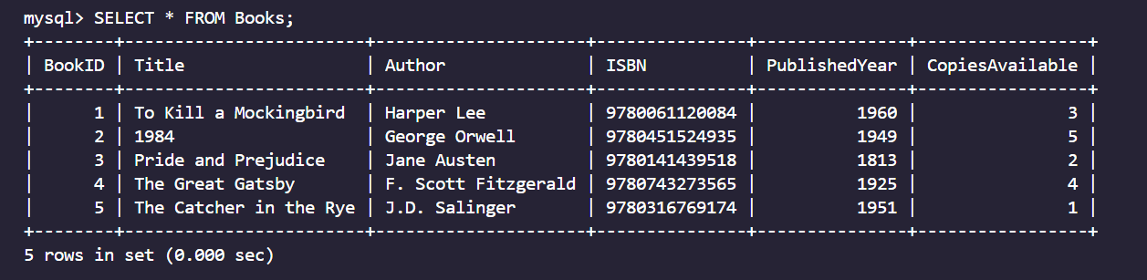

1. Write a query to list all members who joined after a specific date.

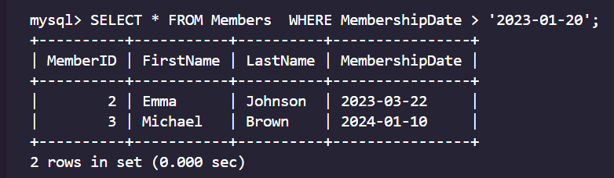

1. Retrieve details of books that have more than 5 copies available.

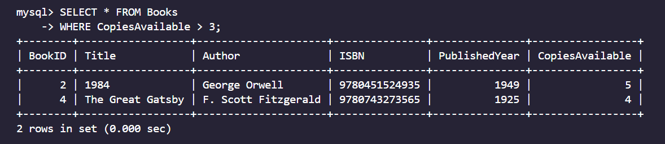

## Part 4: Updating and Deleting

1. Write a query to update the number of available copies for a book after it is loaned out.

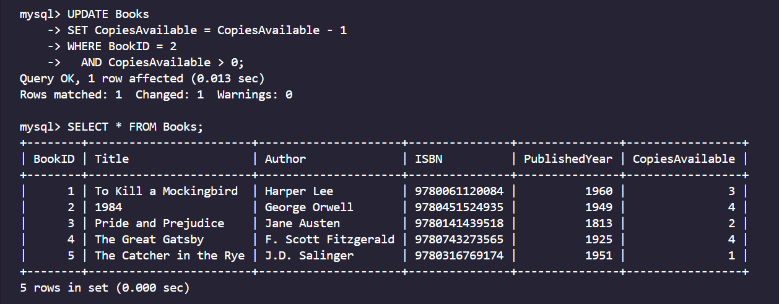

1. Write a query to delete a member who has not borrowed any books.

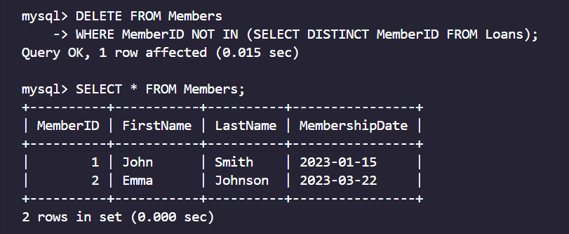

## Part 5: Joins

1. Write a query to list the names of members and the titles of books they have borrowed.

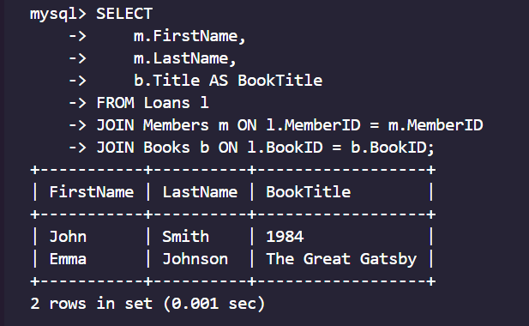

1. Write a query to count how many books each member has borrowed.

